VPC---> Virtual Private Cloud:
Structure:
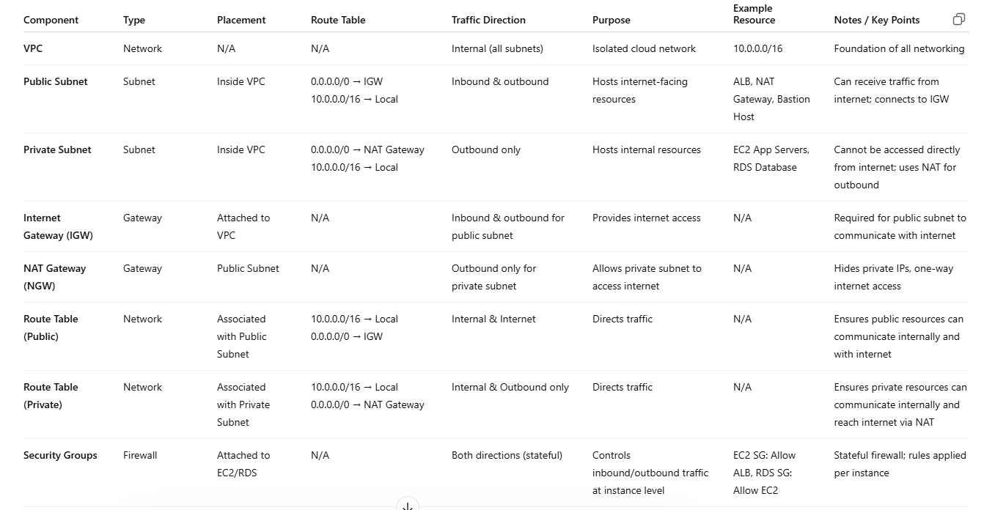
-----------------------------------------------------------------------------------------------------------
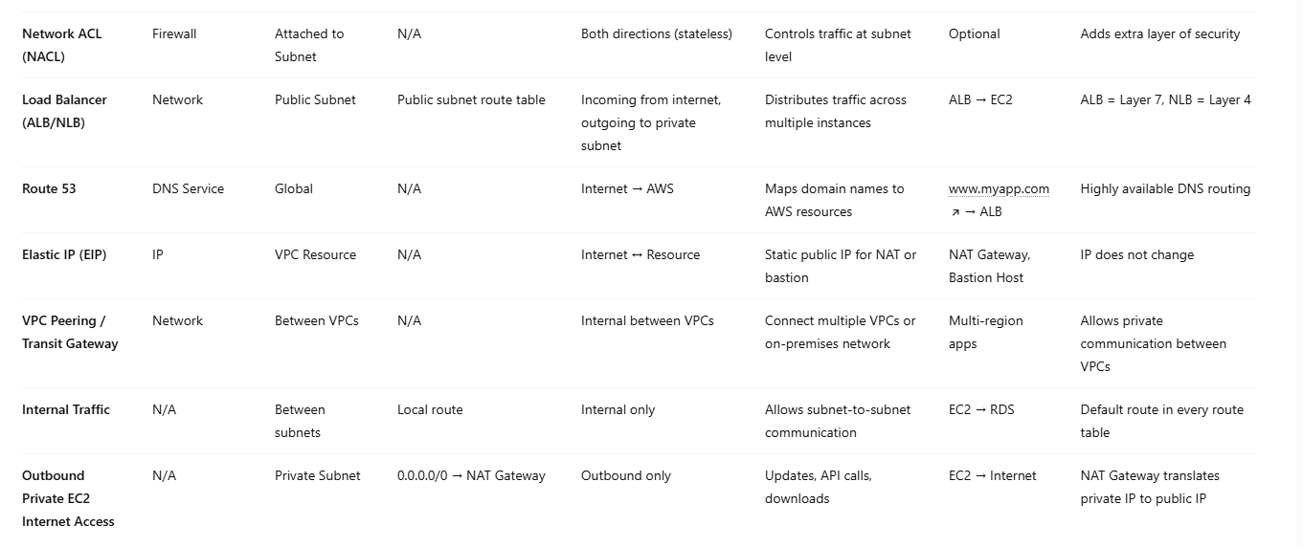
A VPC (Virtual Private Cloud) in Amazon Web Services is your own private network in the cloud where you can launch and control resources like servers, databases, and applications.

What is the Use of VPC?
VPC is mainly used for security, control, and organization of cloud resources.
1. Security
You decide:
Who can access your servers
Which resources are public/private
Example:
Website → public
Database → private (hidden from internet)

Simple Real-World Analogy:
Imagine a company office:
VPC = Entire office building
Subnets = Different rooms (HR, Finance, IT)
Security Groups = Door locks
Internet Gateway = Main entrance
NAT Gateway = One-way exit door

In One Sentence
VPC is used to securely run and manage applications in a private, controlled network inside AWS.

-------------------------------------
While creating VPC we have two options
1. VPC only
Choose this if you want full control.
Creates only the VPC
You must manually create:
Subnets
Route tables
Internet Gateway
NAT Gateway (if needed)
Best for:
Custom architectures
Learning networking deeply
Production setups with specific design

---> Use this if you know what you're doing or need customization.

2. VPC and more (recommended for most cases)

This is a quick setup (wizard).
Automatically creates:
Public & private subnets (across AZs)
Route tables
Internet Gateway
NAT Gateway
Gives you a ready-to-use network
Best for:
Beginners
Quick deployments
Standard architectures (like web apps)
---> Use this if you want AWS to handle the networking setup for you.

Youtub link: https://youtu.be/aDeBcjln59E?si=pOZXlH0X3MIhuPe- (Create VPC, Subnet, router, internal gateway)
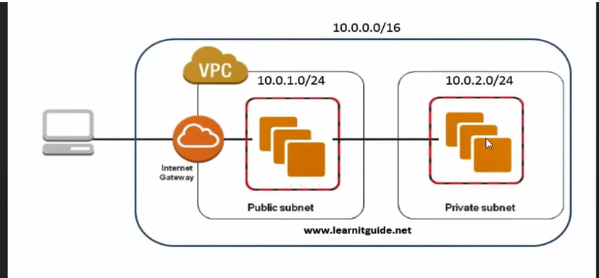
In above SS public subnet is connected to Intern at Gateway
VPC Creation:
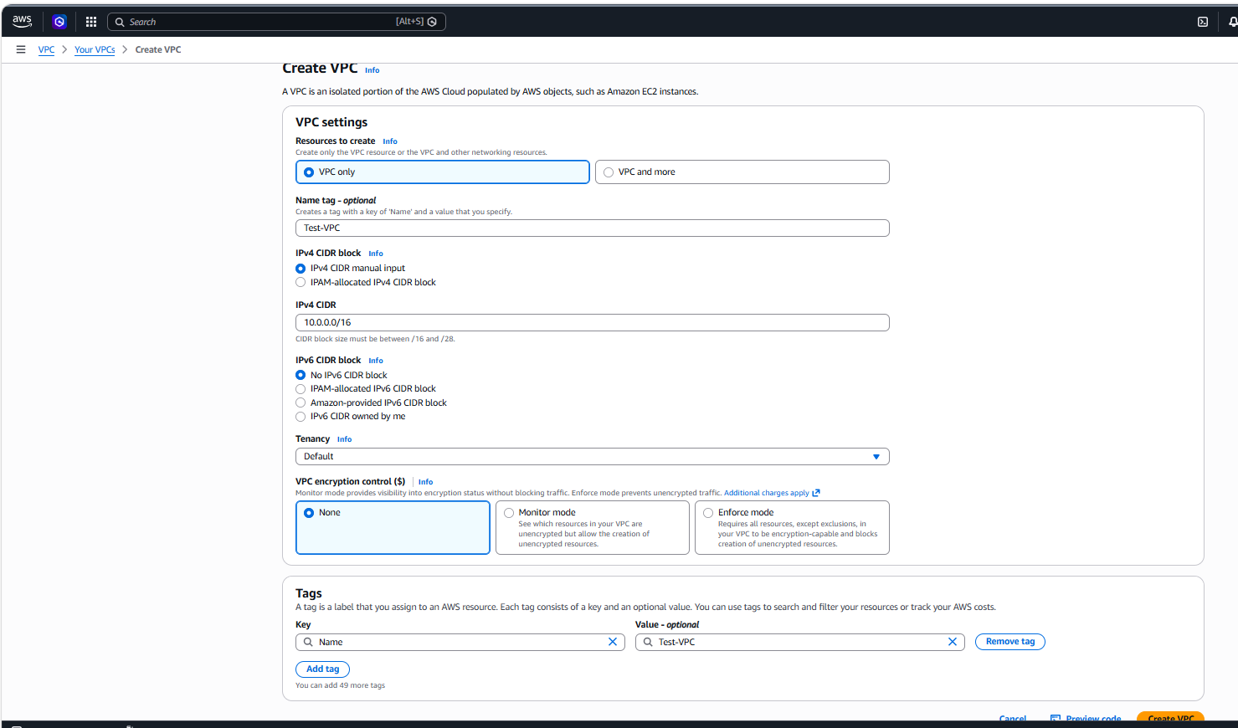
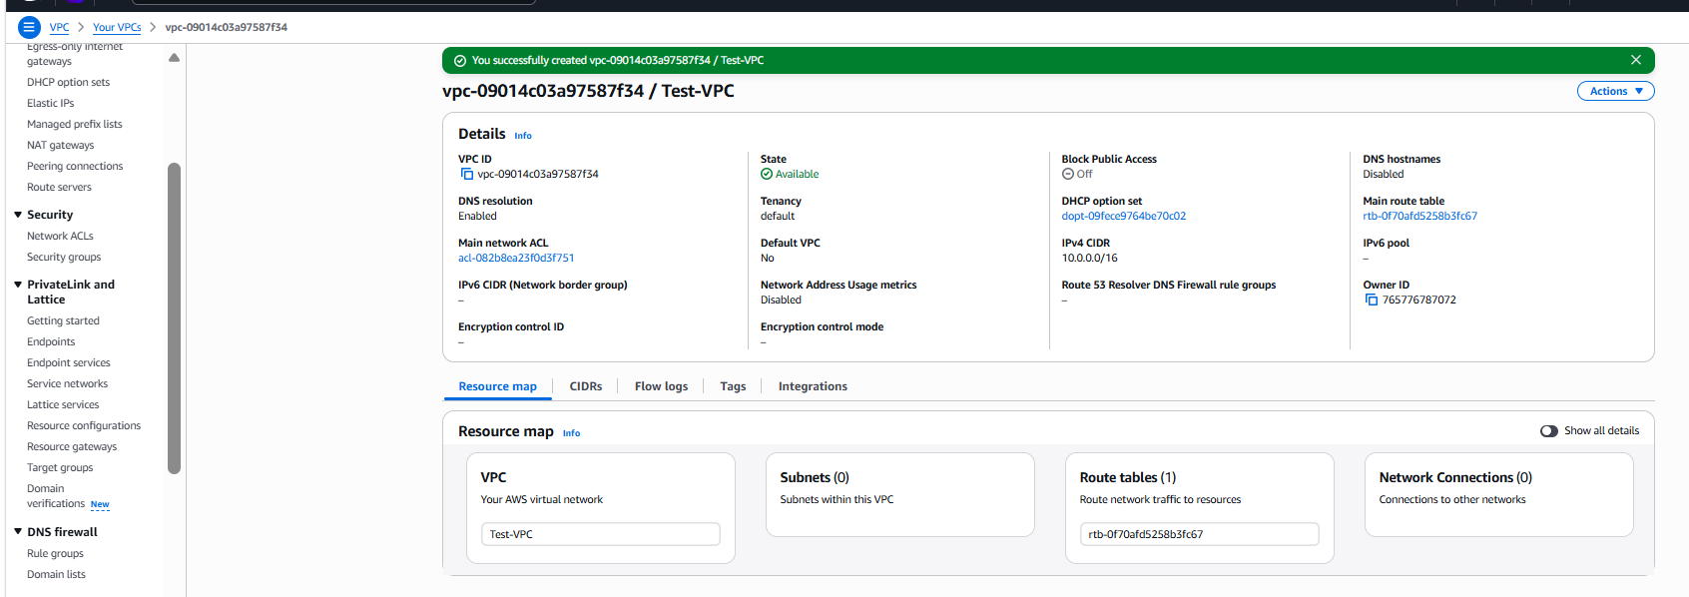

Create subnet:
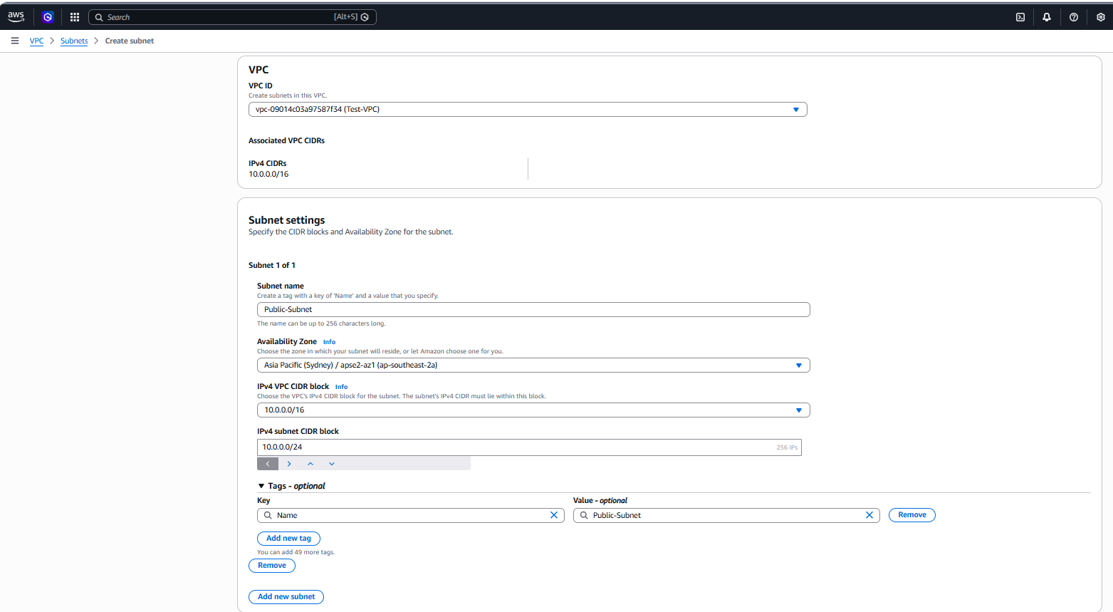
Private Subnet:
Here we need to change the number IPv4 subnet CIDR block: 10.0.1.0/24
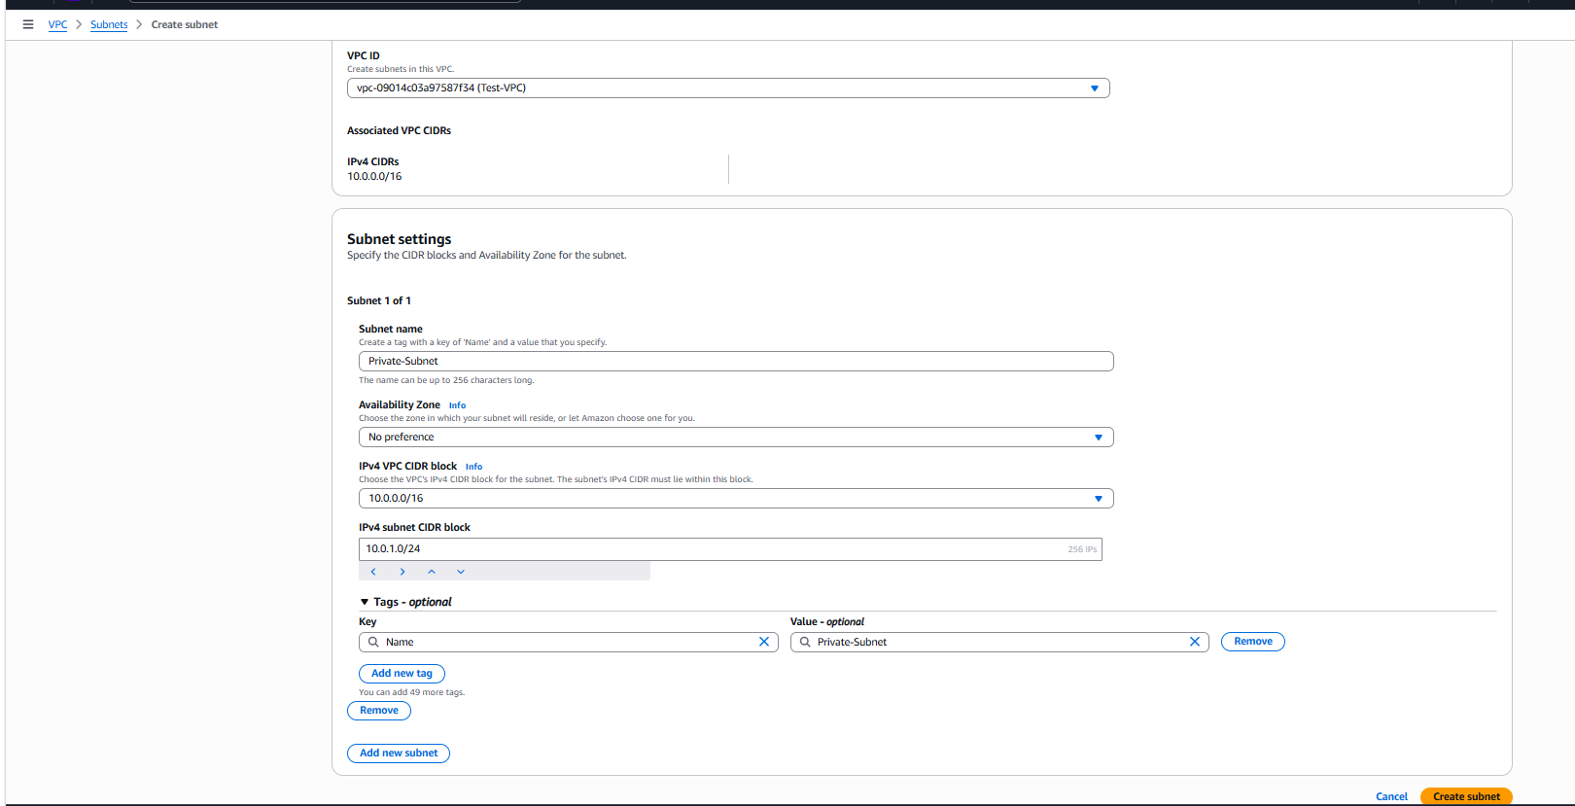
Create internet gateway:
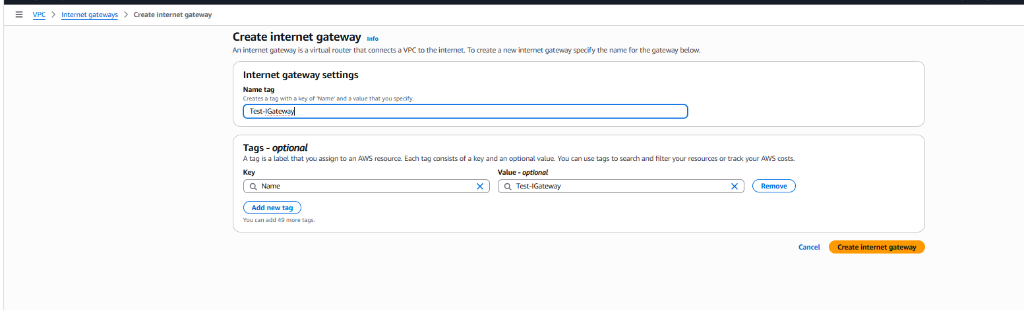
State showing as Detached
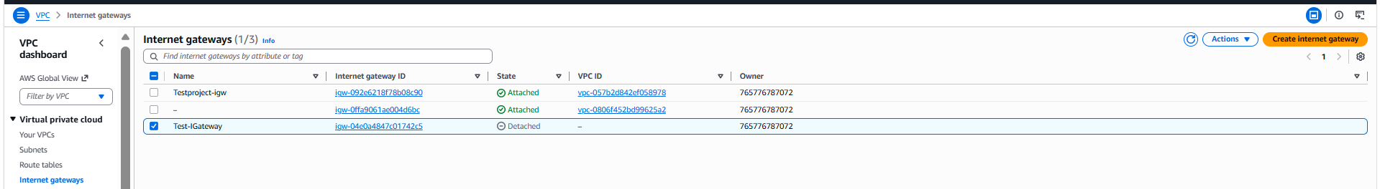
After creation of internet gateway needs to attach our VPC
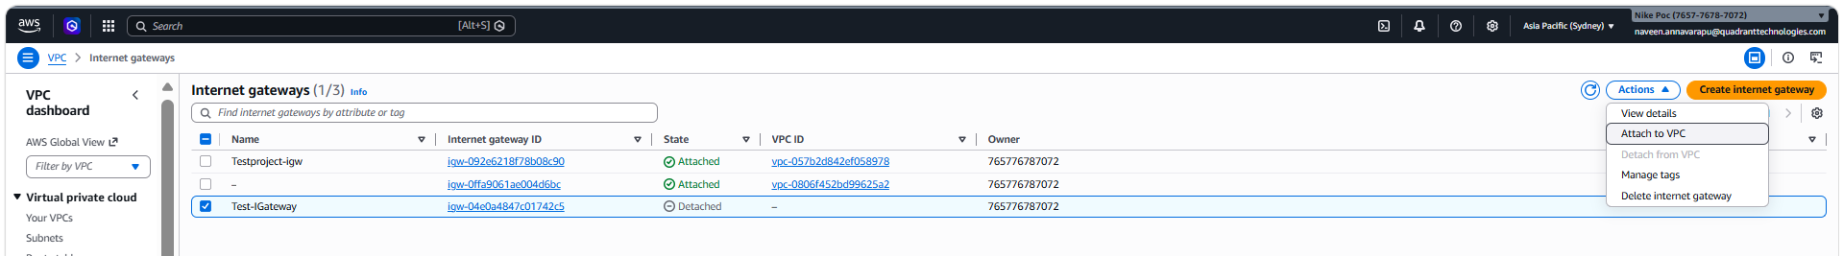

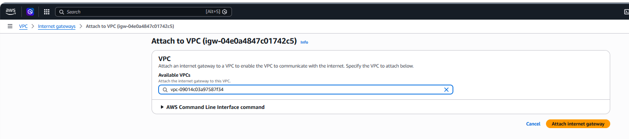

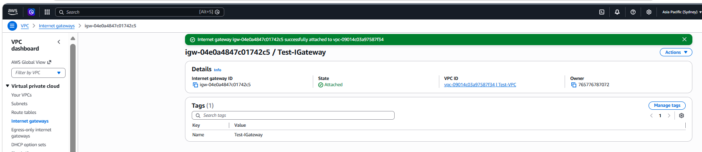
Create route table:
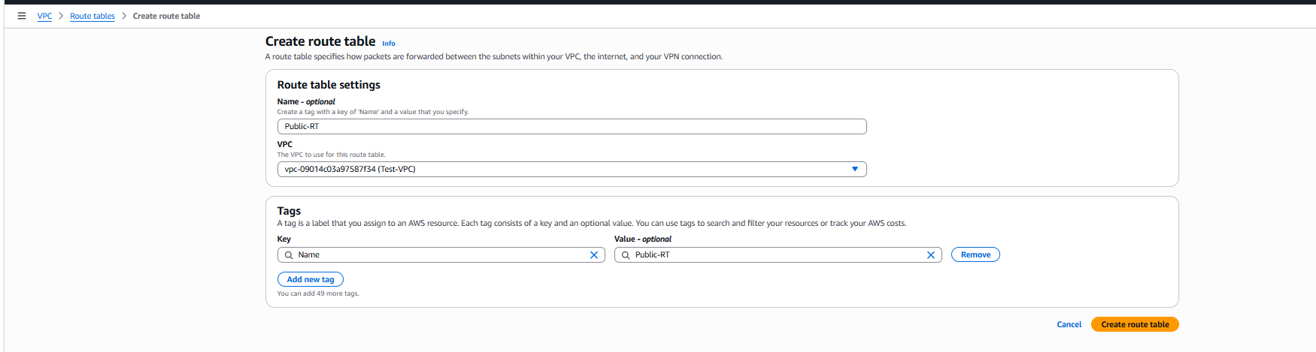
After Create Route table needs to Subnet associations for particular subnet
Subnet associations---- Edit Subnet associations
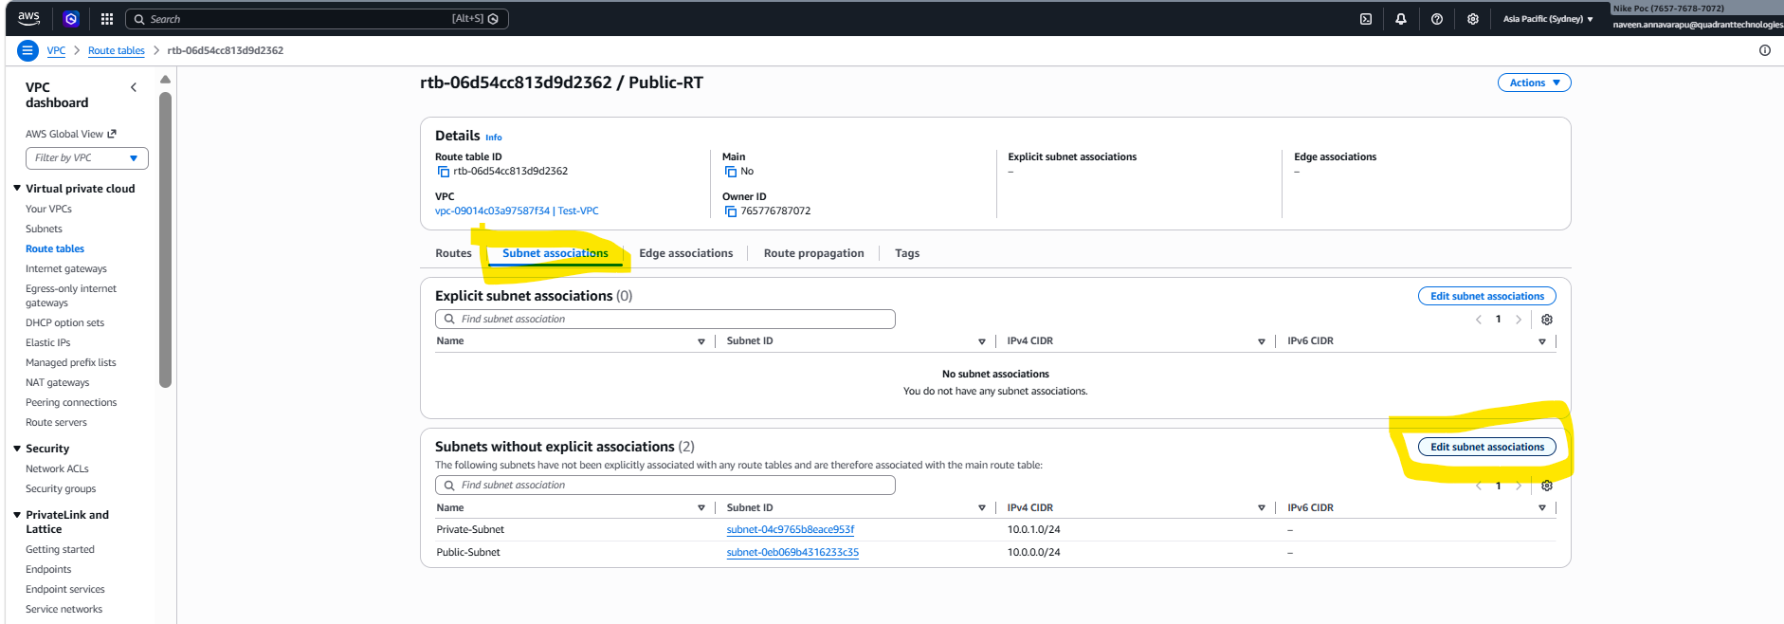
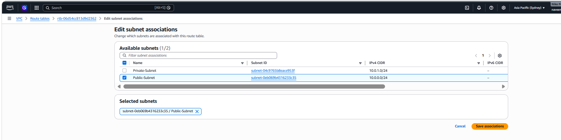
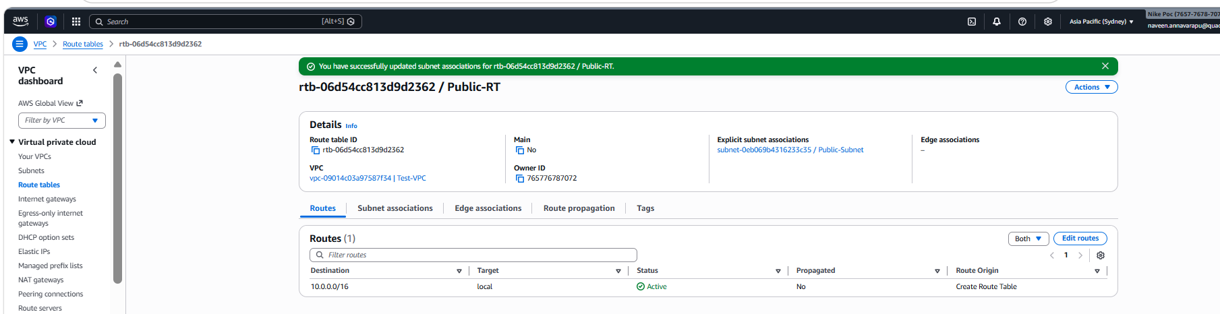

Next step needs to link Internal Gateway to that Public Subnet
Route tables--Routes---- Edit routes--Add Route
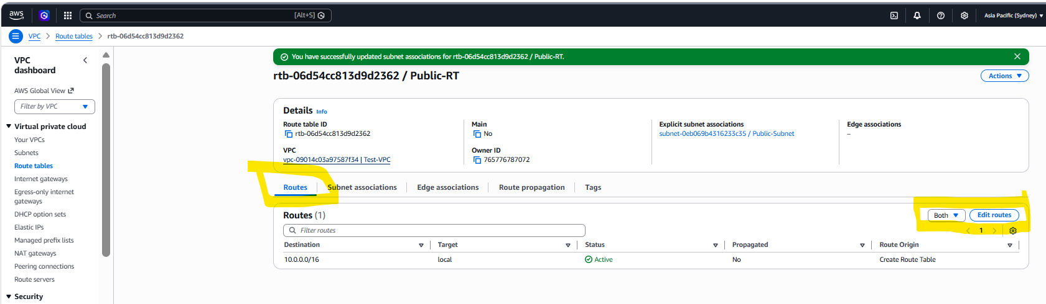

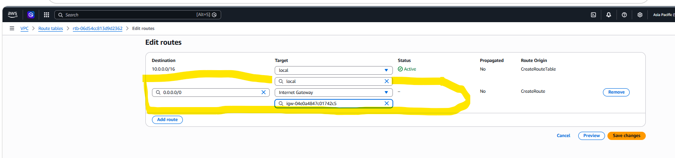
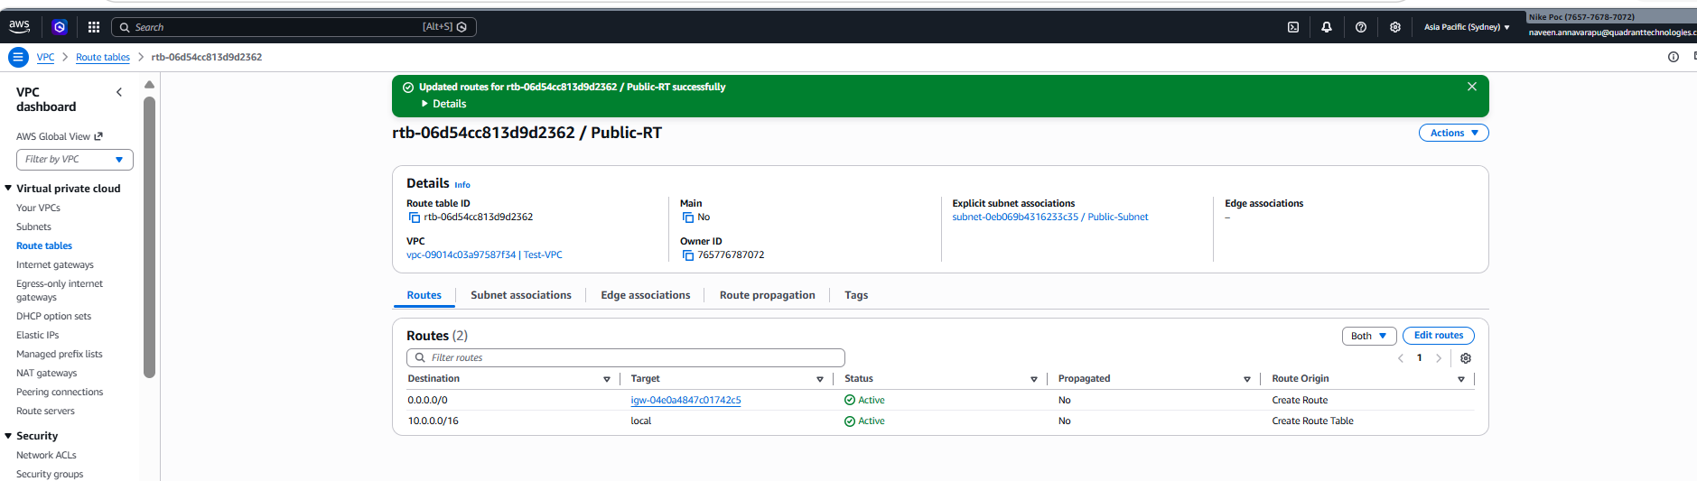

This VPC needs to select while creating of EC2 Instance
EC2 Instance:
EC2 Instance--Lunch Instance on that we have Network Settings-Edit
In that select our VPC and subnet
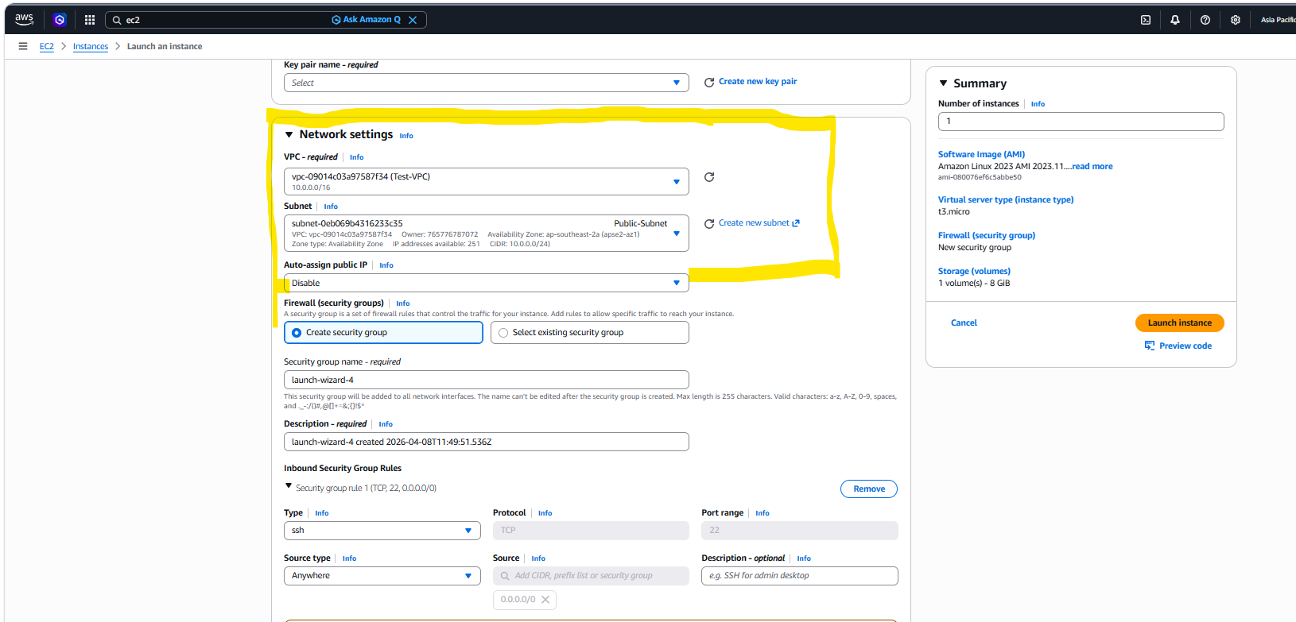

After Creation EC2 Instance if we connect means public subnet will be connect but private subnet not able to connect because in public subnet we attached Internal Gateway.
EC2 Instance--Connect--SSH Client
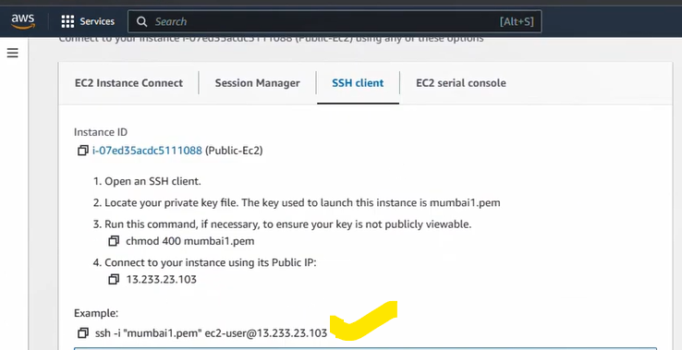
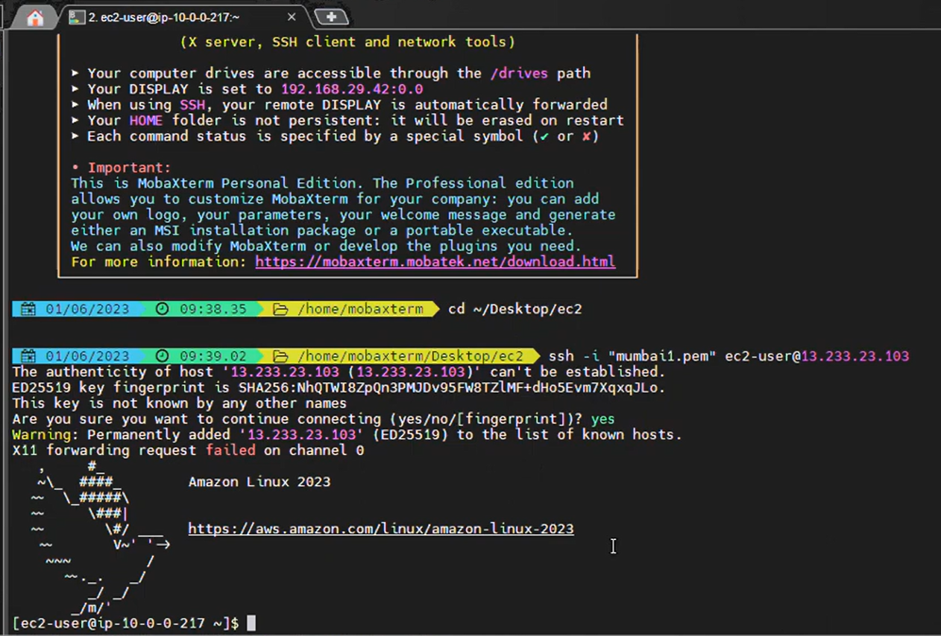

Private EC2 Instance Connect:
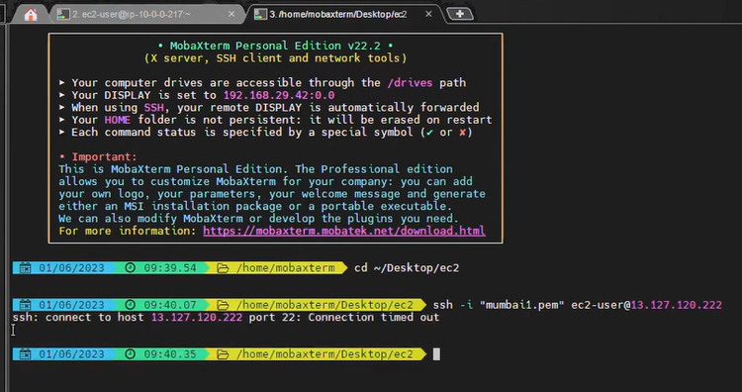

AWS Networking (Deep Explanation)
🧱 1. What is a VPC?
🔹 Amazon VPC
A VPC is your private network inside AWS.
👉 Think of it like:
Your own “data center network” in the cloud
You control:
- IP address range
- Subnets
- Routing
- Security

🏠 2. Create a VPC (Example)
Let’s say you create a VPC:
- CIDR block: 10.0.0.0/16
👉 This means:
- You have 65,536 IP addresses

🧩 3. Subnets (Public vs Private)
A subnet is a smaller network inside VPC.
Example:
Split your VPC like this:
Subnet Type | CIDR | Purpose
Public Subnet | 10.0.1.0/24 | Web servers
Private Subnet | 10.0.2.0/24 | Database

🔹 Public Subnet
- Has internet access
- Used for:
  - Web servers
  - Load balancers
🔹 Private Subnet
- No direct internet access
- Used for:
  - Databases
  - Backend services

🚦 4. Route Tables
Route tables decide:
👉 “Where should traffic go?”
Each subnet is linked to a route table.

Example Route Table:
Public Route Table
Destination | Target
10.0.0.0/16 | Local
0.0.0.0/0 | Internet Gateway
👉 This allows internet access

Private Route Table
Destination | Target
10.0.0.0/16 | Local
👉 No internet access (yet)

🌍 5. Internet Gateway (IGW)
🔹 What is it?
A gateway that connects your VPC to the internet.
👉 Without this → No internet

Steps:
- Create Internet Gateway
- Attach it to VPC
- Add route:
  - 0.0.0.0/0 → IGW

🔁 6. NAT Gateway (Important)
🔹 Problem:
Private subnet cannot access internet.
🔹 Solution:
Use a NAT Gateway
👉 Allows:
- Private servers → access internet
- Internet → cannot access private servers

🔹 NAT Gateway

Example Setup:
- NAT Gateway placed in public subnet
- Private route table updated:
Destination | Target
0.0.0.0/0 | NAT Gateway

⚖️ 7. Load Balancers
🔹 Why needed?
Distribute traffic across multiple servers.

Types:
🔹 Application Load Balancer
- Works at HTTP/HTTPS level
- Smart routing (based on URL)
🔹 Network Load Balancer
- High performance
- TCP/UDP traffic

Example:
- 3 EC2 instances (web servers)
- Load balancer distributes traffic
👉 If 1 server fails → no problem

🌐 8. DNS with Route 53
🔹 Amazon Route 53
It converts:
👉 Domain name → IP address

Example:
- User enters: www.myapp.com
- Route 53 sends request to:
  - Load Balancer

🧠 Full Architecture Example (Real-World)
Let’s build a simple web app:

🏗️ Architecture:
- VPC → 10.0.0.0/16
- Public Subnet
  - Load Balancer
  - NAT Gateway
- Private Subnet
  - EC2 instances (app servers)
  - Database (RDS)

🔄 Flow:
- User opens website
- DNS (Route 53) → Load Balancer
- Load Balancer → EC2 (private subnet)
- EC2 → Database
- EC2 → Internet (via NAT if needed)

🔐 Security Layer
- Security Groups (instance-level firewall)
- NACLs (subnet-level firewall)

🧩 Simple Analogy
AWS Concept | Real Life
VPC | Your apartment building
Subnet | Rooms
Internet Gateway | Main gate
NAT Gateway | Security guard
Load Balancer | Receptionist
Route 53 | Address book

🎯 Key Points to Remember
- VPC = network
- Subnet = smaller network
- Public subnet = internet access
- Private subnet = secure backend
- IGW = internet entry/exit
- NAT = private → internet only
- Load balancer = distribute traffic
- Route 53 = DNS

Complete AWS Networking Table:
Component | Type | Placement | Route Table | Traffic Direction | Purpose | Example Resource | Notes / Key Points
VPC | Network | N/A | N/A | Internal (all subnets) | Isolated cloud network | 10.0.0.0/16 | Foundation of all networking
Public Subnet | Subnet | Inside VPC | 0.0.0.0/0 → IGW 10.0.0.0/16 → Local | Inbound & outbound | Hosts internet-facing resources | ALB, NAT Gateway, Bastion Host | Can receive traffic from internet; connects to IGW
Private Subnet | Subnet | Inside VPC | 0.0.0.0/0 → NAT Gateway 10.0.0.0/16 → Local | Outbound only | Hosts internal resources | EC2 App Servers, RDS Database | Cannot be accessed directly from internet; uses NAT for outbound
Internet Gateway (IGW) | Gateway | Attached to VPC | N/A | Inbound & outbound for public subnet | Provides internet access | N/A | Required for public subnet to communicate with internet
NAT Gateway (NGW) | Gateway | Public Subnet | N/A | Outbound only for private subnet | Allows private subnet to access internet | N/A | Hides private IPs, one-way internet access
Route Table (Public) | Network | Associated with Public Subnet | 10.0.0.0/16 → Local 0.0.0.0/0 → IGW | Internal & Internet | Directs traffic | N/A | Ensures public resources can communicate internally and with internet
Route Table (Private) | Network | Associated with Private Subnet | 10.0.0.0/16 → Local 0.0.0.0/0 → NAT Gateway | Internal & Outbound only | Directs traffic | N/A | Ensures private resources can communicate internally and reach internet via NAT
Security Groups | Firewall | Attached to EC2/RDS | N/A | Both directions (stateful) | Controls inbound/outbound traffic at instance level | EC2 SG: Allow ALB, RDS SG: Allow EC2 | Stateful firewall; rules applied per instance
Network ACL (NACL) | Firewall | Attached to Subnet | N/A | Both directions (stateless) | Controls traffic at subnet level | Optional | Adds extra layer of security
Load Balancer (ALB/NLB) | Network | Public Subnet | Public subnet route table | Incoming from internet, outgoing to private subnet | Distributes traffic across multiple instances | ALB → EC2 | ALB = Layer 7, NLB = Layer 4
Route 53 | DNS Service | Global | N/A | Internet → AWS | Maps domain names to AWS resources | www.myapp.com → ALB | Highly available DNS routing
Elastic IP (EIP) | IP | VPC Resource | N/A | Internet ↔ Resource | Static public IP for NAT or bastion | NAT Gateway, Bastion Host | IP does not change
VPC Peering / Transit Gateway | Network | Between VPCs | N/A | Internal between VPCs | Connect multiple VPCs or on-premises network | Multi-region apps | Allows private communication between VPCs
Internal Traffic | N/A | Between subnets | Local route | Internal only | Allows subnet-to-subnet communication | EC2 → RDS | Default route in every route table
Outbound Private EC2 Internet Access | N/A | Private Subnet | 0.0.0.0/0 → NAT Gateway | Outbound only | Updates, API calls, downloads | EC2 → Internet | NAT Gateway translates private IP to public IP

